EXP 8.1

NAME: RAMA SUBRAMANIYAN.V
REG.NO: 192419051
COURSE CODE: ECA0910
COURSE NAME: DIGITAL SIGNAL PROCESSING
PRACTICAL LAB RESULTS

CODE:

clc;
clear;
close all;
% Original Sequence
n = 0:40;
x = sin(0.3*pi*n);
% Decimation by 2
y = x(1:2:end);
nd = 0:length(y)-1;
% Interpolation by 2
v = zeros(1,2*length(x));
v(1:2:end) = x;
ni = 0:length(v)-1;
% Figure 1: Original Sequence
figure;
stem(n,x,'filled');
grid on;
title('Original Sequence x[n]');
xlabel('n');
ylabel('Amplitude');
% Figure 2: Decimated Sequence
figure;
stem(nd,y,'filled');
grid on;
title('Decimated Sequence by 2');
xlabel('n');
ylabel('Amplitude');
% Figure 3: Interpolated Sequence
figure;
stem(ni,v,'filled');
grid on;
title('Interpolated Sequence by 2');
xlabel('n');
ylabel('Amplitude');
% Figure 4: Comparison
figure;
stem(n,x,'b'); hold on;
stem(0:2:length(v)-2,v(1:2:end),'r');
legend('Original x[n]','Interpolated Samples');
grid on;
title('Comparison of Sequences');
xlabel('n');
ylabel('Amplitude');

OUTPUT:
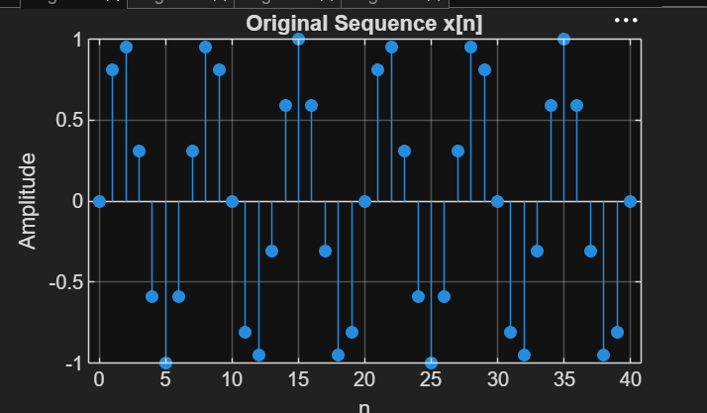

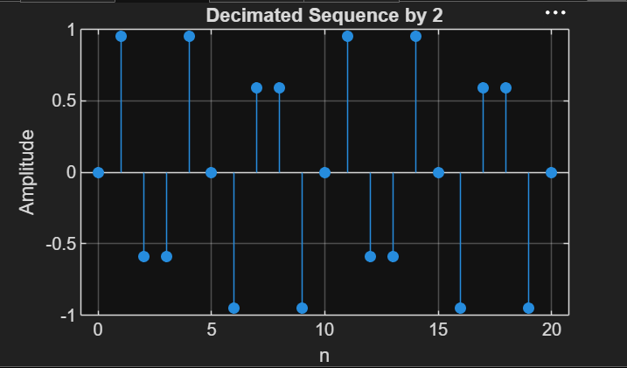

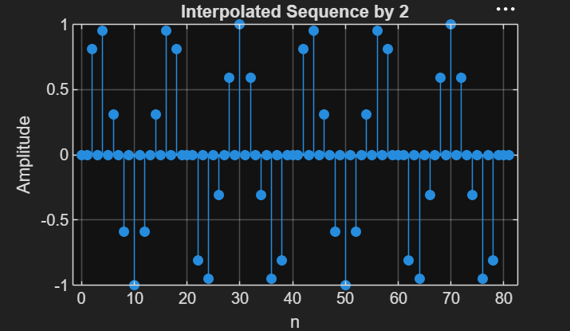

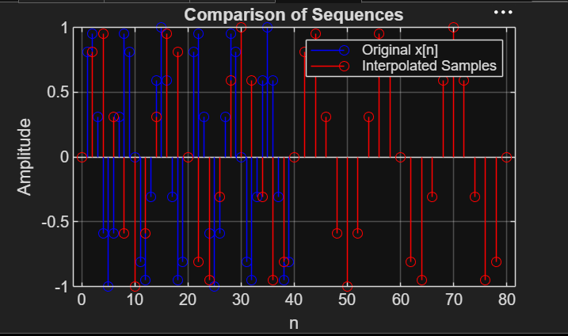

EXP 8.2

CODE:

clc;
clear;
close all;
%% Input Signal
Fs = 1000; % Sampling Frequency
t = 0:1/Fs:1; % Time Vector
% Test Signal
x = sin(2*pi*50*t) + 0.5*sin(2*pi*120*t);
%% FIR Low-Pass Filter Design
N = 20; % Filter Order
Fc = 0.4; % Normalized Cutoff Frequency
h = fir1(N,Fc,hamming(N+1));
%% Decimation Factor
M = 2;
% Polyphase Decimation
y_dec = upfirdn(x,h,1,M);
%% Interpolation Factor
L = 2;
% Polyphase Interpolation
y_int = upfirdn(y_dec,h,L,1);
%% Adjust Length for Comparison
if length(y_int) > length(x)
y_int = y_int(1:length(x));
elseif length(y_int) < length(x)
x = x(1:length(y_int));
end
%% Time Axes
t1 = (0:length(x)-1)/Fs;
t2 = (0:length(y_dec)-1)/(Fs/M);
t3 = (0:length(y_int)-1)/Fs;
%% BEST GRAPH OUTPUT
figure('Name','Polyphase Decimation and Interpolation','NumberTitle','off');
% Original Signal
subplot(4,1,1)
plot(t1,x,'b','LineWidth',1.5)
title('Original Input Signal')
xlabel('Time (s)')
ylabel('Amplitude')
grid on
% Decimated Signal
subplot(4,1,2)
stem(t2,y_dec,'r','filled')
title('Decimated Signal (M = 2)')
xlabel('Time (s)')
ylabel('Amplitude')
grid on
% Interpolated Signal
subplot(4,1,3)
plot(t3,y_int,'k','LineWidth',1.5)
title('Interpolated/Reconstructed Signal (L = 2)')
xlabel('Time (s)')
ylabel('Amplitude')
grid on
% Comparison
subplot(4,1,4)
plot(t1,x,'b','LineWidth',1.5)
hold on
plot(t3,y_int,'r--','LineWidth',1.5)
title('Comparison of Original and Reconstructed Signals')
xlabel('Time (s)')
ylabel('Amplitude')
legend('Original Signal','Reconstructed Signal')
grid on
%% Display Information
disp('--------------------------------------');
disp('POLYPHASE DECIMATION & INTERPOLATION');
disp('--------------------------------------');
fprintf('Original Signal Length = %d\n',length(x));
fprintf('Decimated Signal Length = %d\n',length(y_dec));
fprintf('Interpolated Signal Length = %d\n',length(y_int));
%% Separate Figure for Better Visualization
figure;
plot(t1,x,'b','LineWidth',2)
hold on
plot(t3,y_int,'r--','LineWidth',2)
title('Original vs Reconstructed Signal')
xlabel('Time (s)')
ylabel('Amplitude')
legend('Original Signal','Reconstructed Signal')
grid on

OUTPUT:

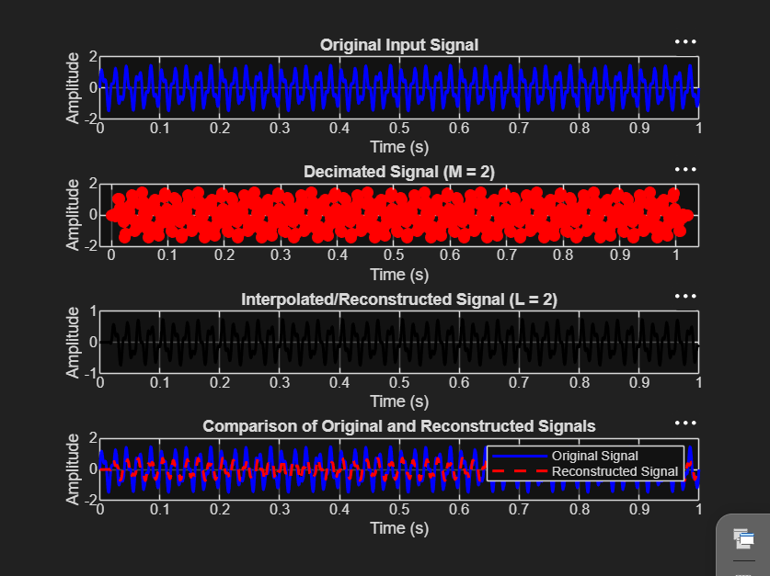

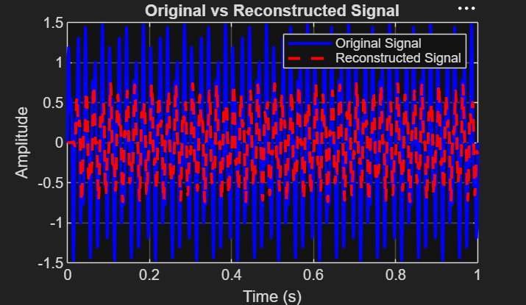

--------------------------------------
POLYPHASE DECIMATION & INTERPOLATION
--------------------------------------
Original Signal Length = 1001
Decimated Signal Length = 511
Interpolated Signal Length = 1001
>>

